In the main Box (scriptbox as an example): Type

* Vim /etc/hosts:

192.168.10.13 web01

192.168.10.14 web02

192.168.10.15 web03

* Save: Escape + :wq + Enter
* ping web01 OR: ping web02 OR: ping web03

**Remote command Execution:**

Now, you can perform remote command execution on all of your machines from any one you are logged into:

**Example:**

ssh vagrant@web01 Where: web01 is the Hostname & vagrant is user

password: vagrant users password is (password) as default

**To activate password login especially on Ubuntu:**

vim /etc/ssh/sshd_config …… look for the line password Authentication and change No to Yes……. Save, Quit and Restart the Ubuntu service (systemctl restart ssh)

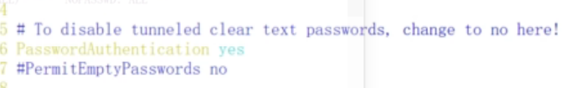

**Adding a User:**

**Centos**

sudo –i

useradd devops

password devops

add the user to sudo’s file: vi sudo

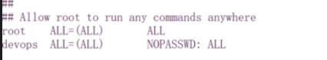

Save and quit

Remote SSH: ssh devops@web02 uptime

**Ubuntu User add:**

adduser devops

password: type your password

add the user to sudo’s file:

export EDITOR=vim

vi sudo

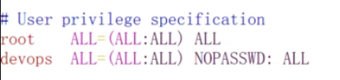

Save and quit

Remote SSH: ssh devops@web03 free –m

CHECK THE DOCUMENT :

Python Fabric(SSH for application deployment or systems administration tasks)

You can find it in the python folder